**Project report**

**Grab Cut:**

We found this task to be very hard, and we ran into some difficulties along the way.

Before stepping into the results, we think our main problem was something with the T – Links, we didn't completely figure it out, but we think performance and accuracy misses mainly came from there, nevertheless we think we achieved not so bad results.

We came to a state where some of the images have given good to almost optimal results and some were on the lower scale of the quality of the wanted results, be that as it may we did our very best to achieve optimal results.

**average time per image is: 1.75 (minute / image).**

Results Table:

|  |  |  |
| --- | --- | --- |
| Image | Accuracy | Jaccard |
| Banana_2 | 97.68 | 90.7 |
| book | 87.7 | 75.0 |
| cross | 44.5 | 36.9 |
| flower | 98.5 | 92.9 |
| Full moon | 97.01 | 67.2 |
| grave | 96.89 | 78.9 |
| llama | 90.09 | 64.9 |
| memorial | 98.2 | 91.1 |
| sheep | 99.28 | 87.8 |
| Stone_2 | 99.4 | 97.8 |
| teddy | 97.2 | 88.4 |
| Banana_1 | 60.02 | 39.05 |
| bush | 79.4 | 44.8 |

Results in next page….

**Images Comparison: resulting image – resulting mask – ground truth mask**

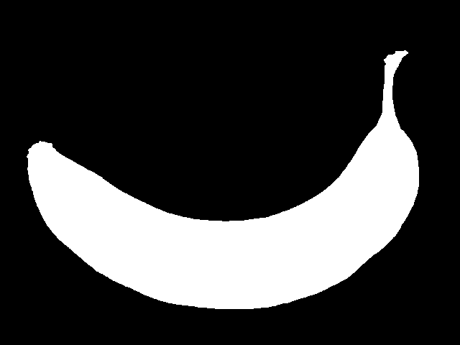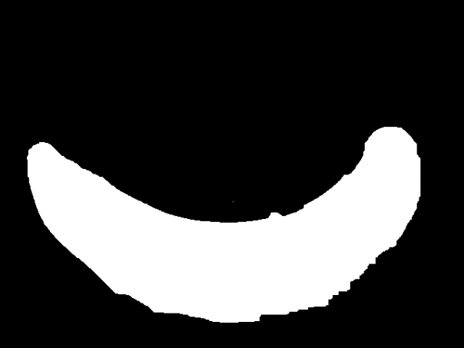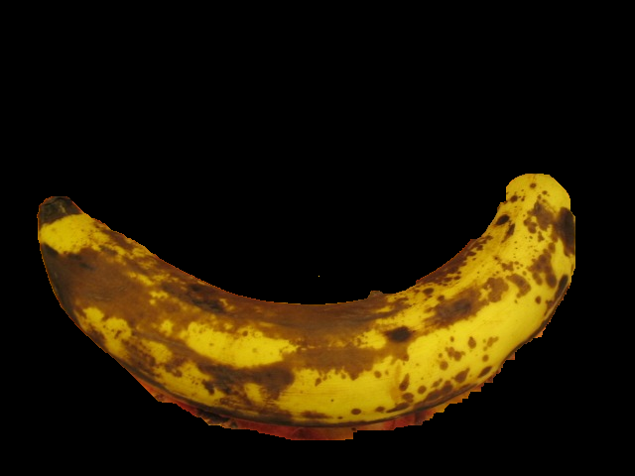

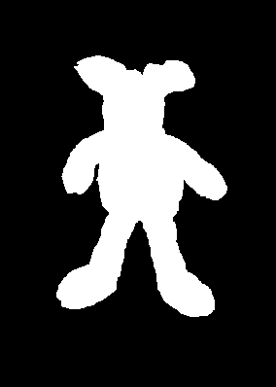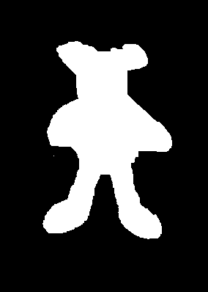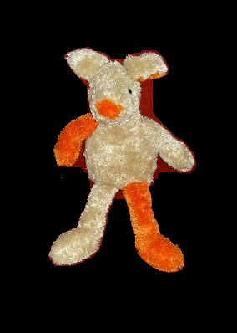

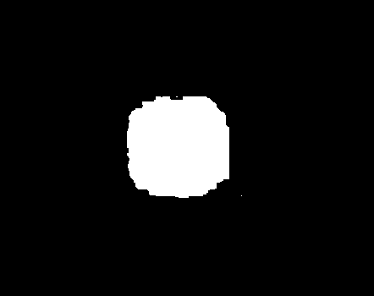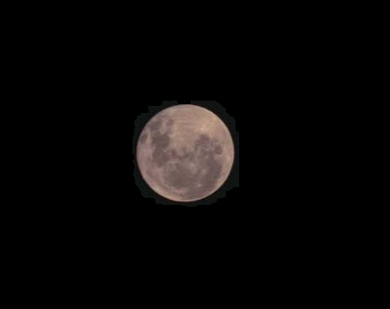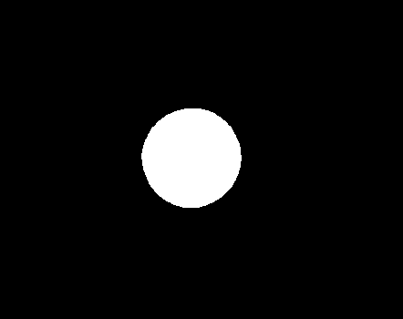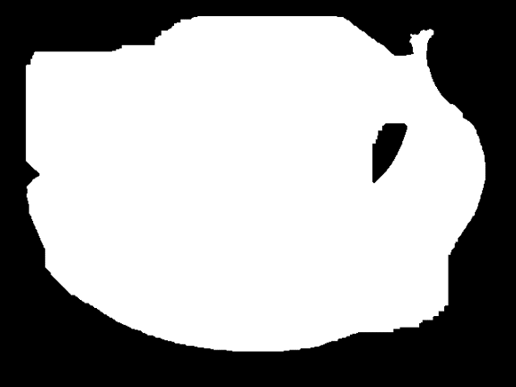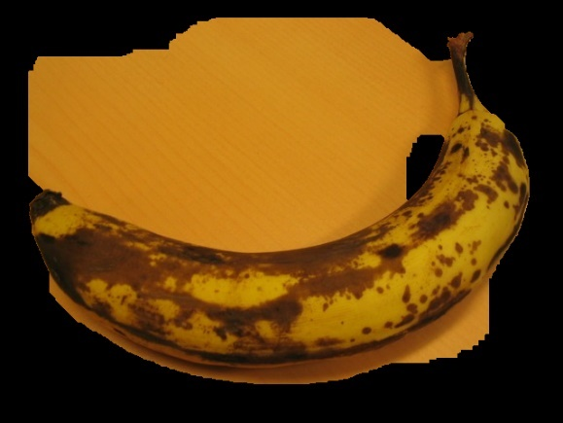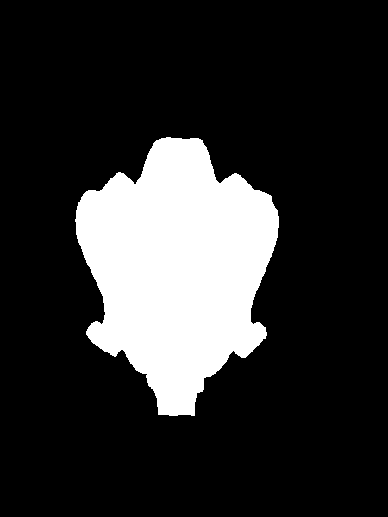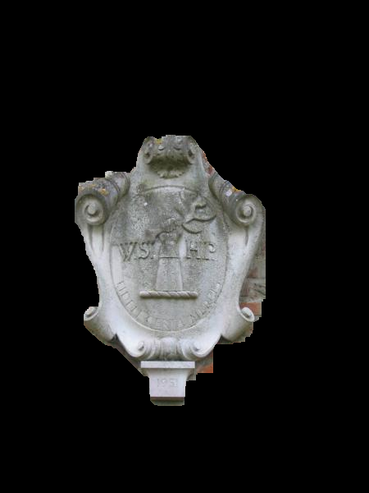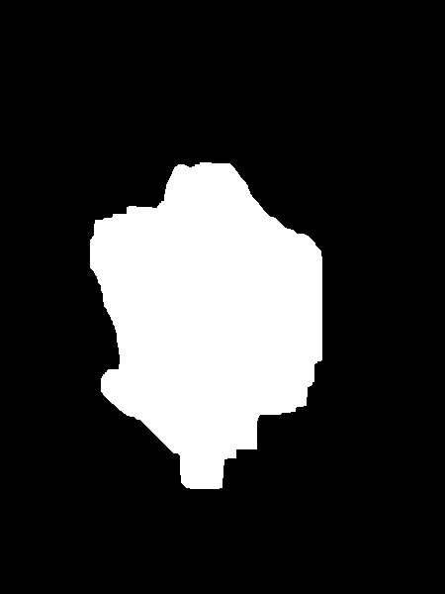

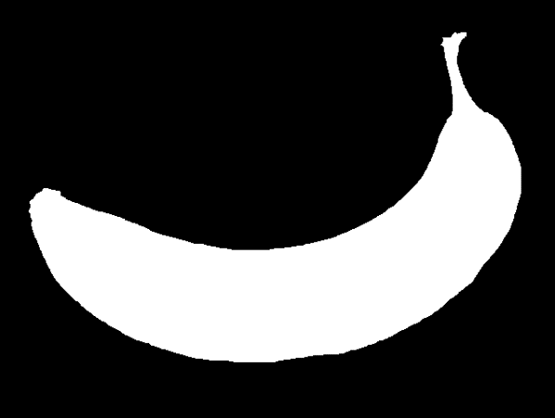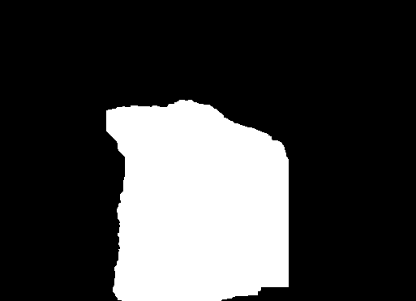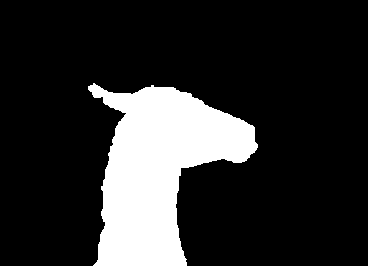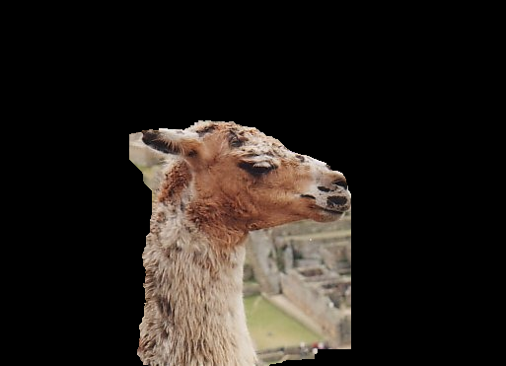

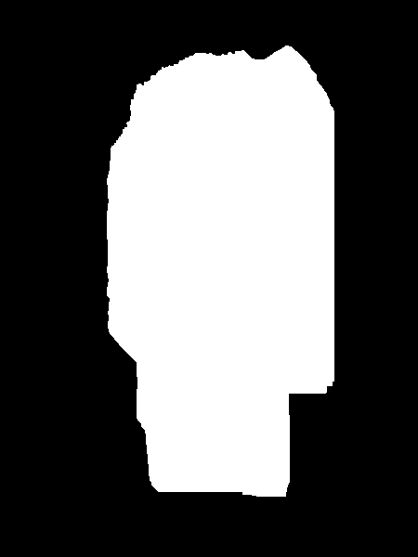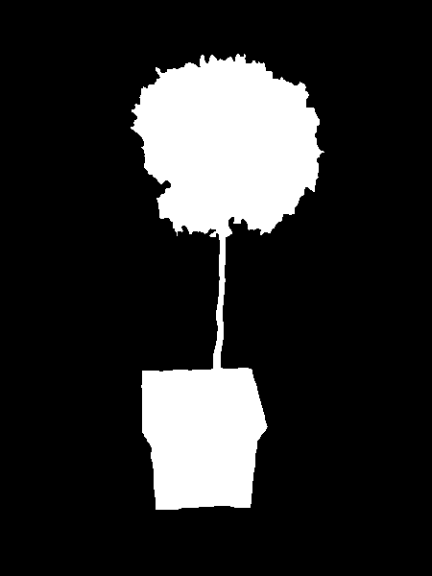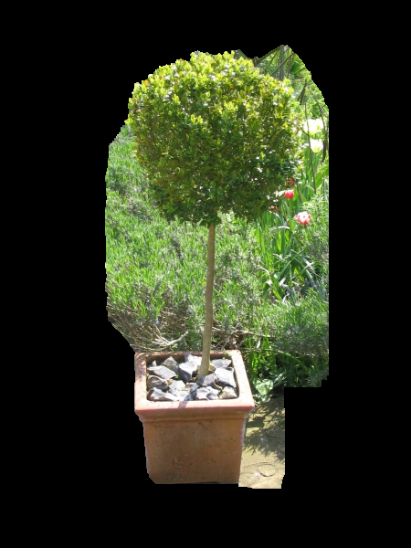

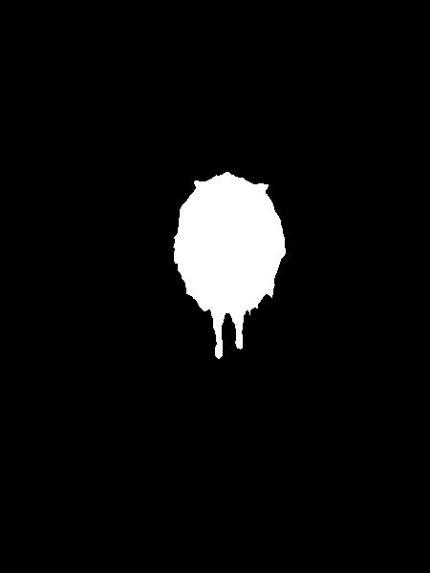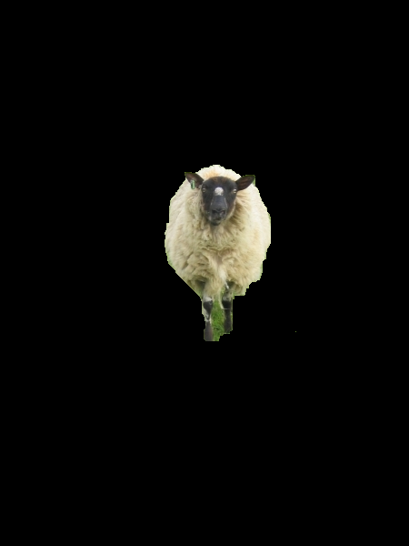

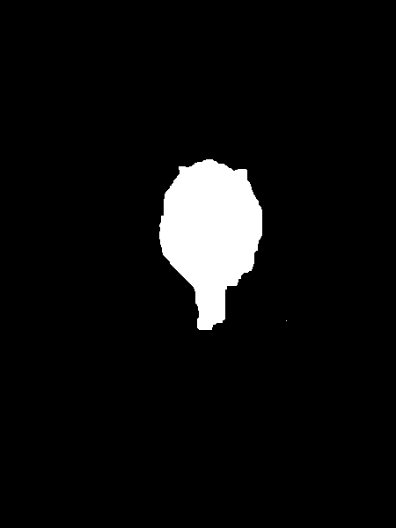

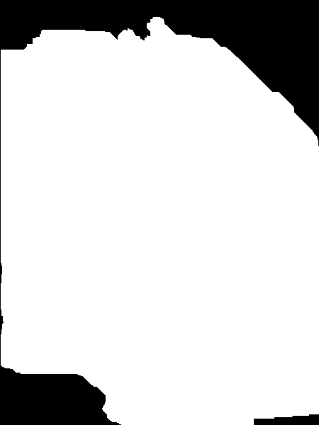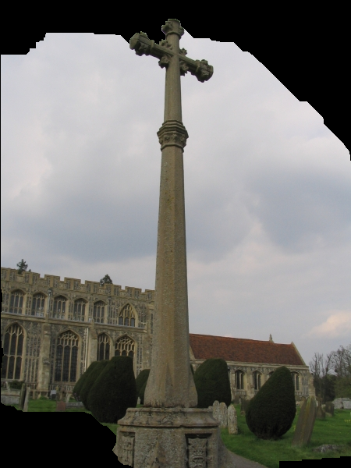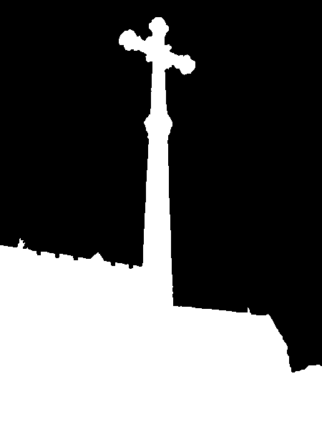

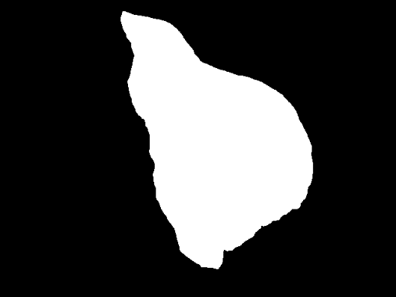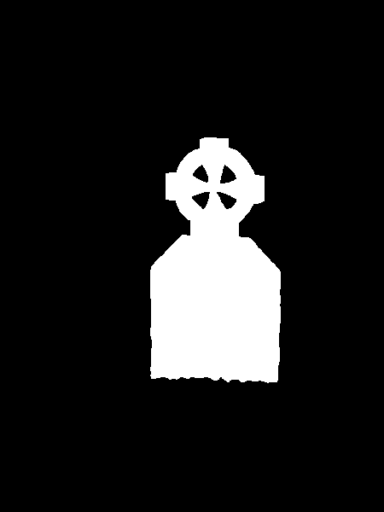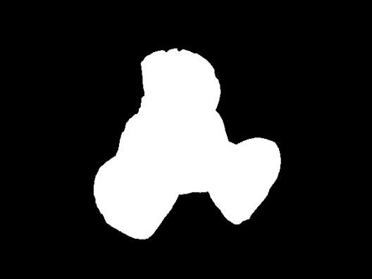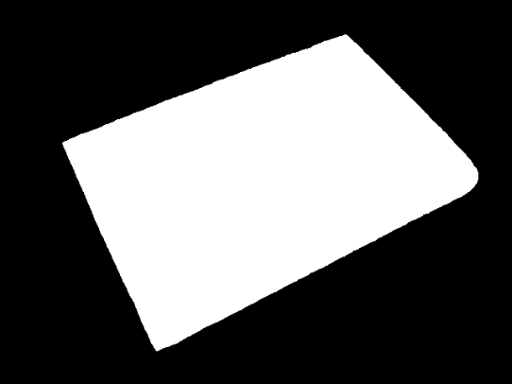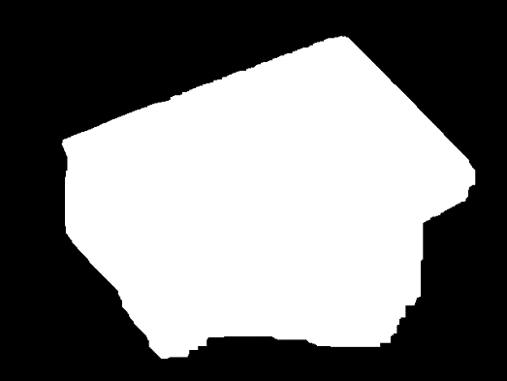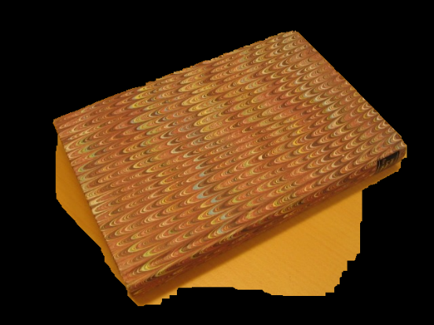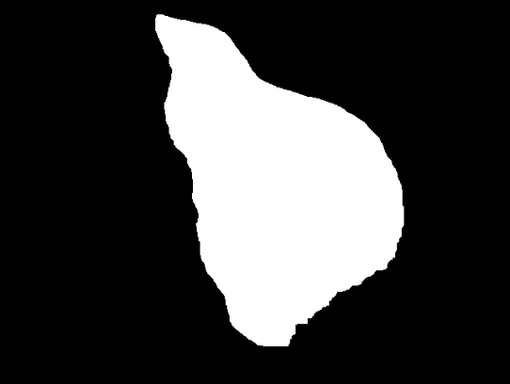 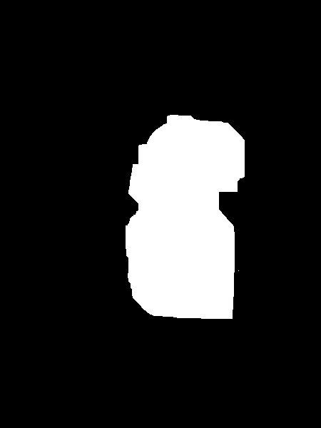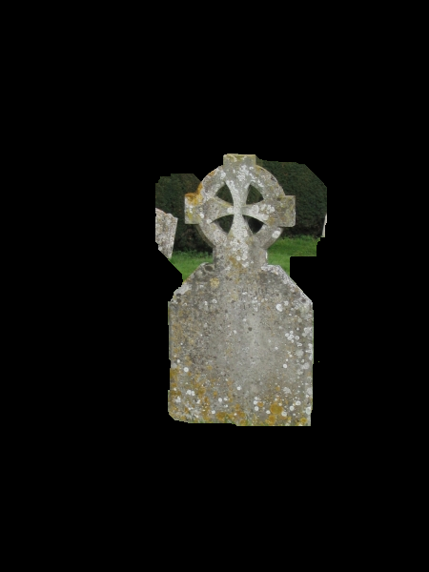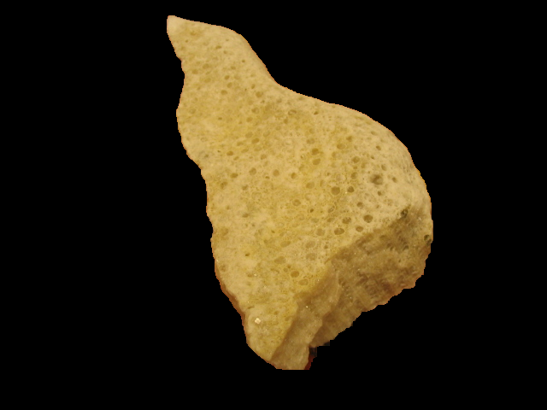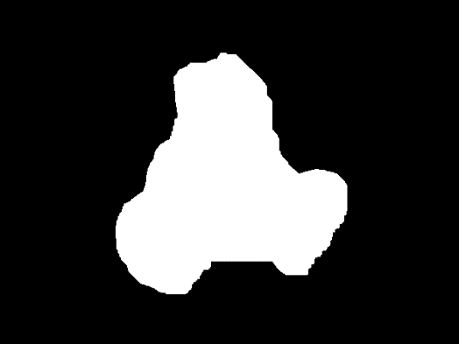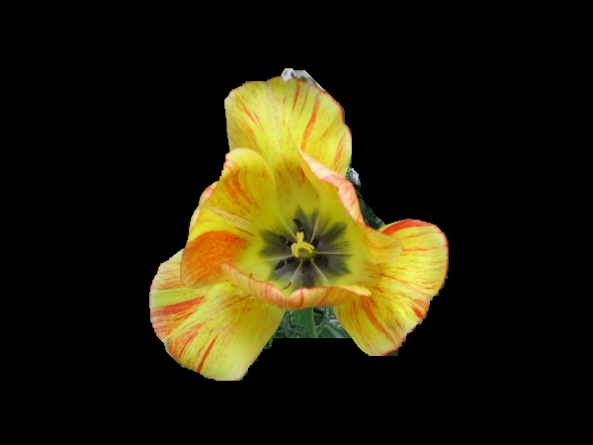

Params discussion:

I run the algorithm over 2 images flower, and sheep which in general we had good results for them, and I tried to play with the params:

Number of GMM's: When I tried 10 GMM's it's didn't affect the results a lot.

But in contrast to what I was expecting 2 GMM's actully achived great results (better than 5). The following images created with 2 GMM's:

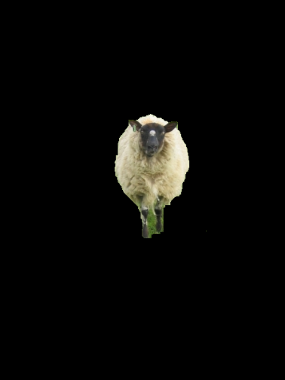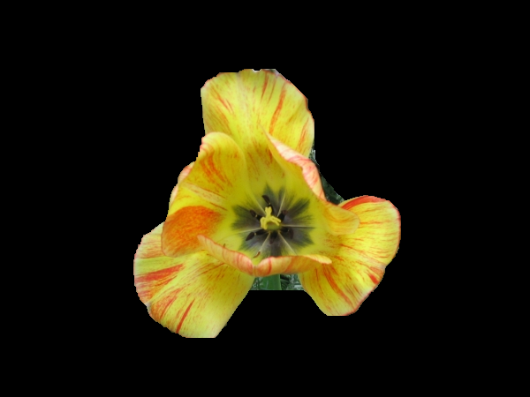One iterations: expected poor results, got: (Less than one mitnute per image !!!)



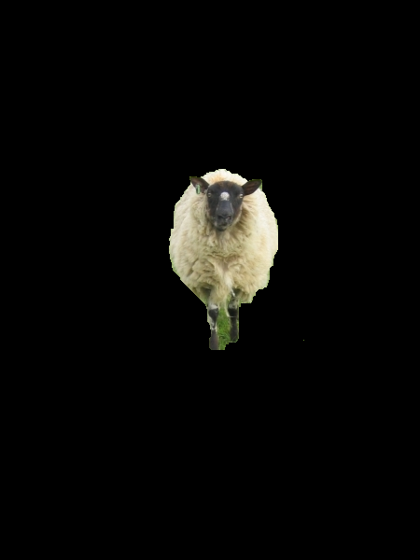

Different init rectangle – bigger rectangle:

Here as expected we got poor results, since the inititalization rectangle is not really fit the flower: (100 20 550 500)

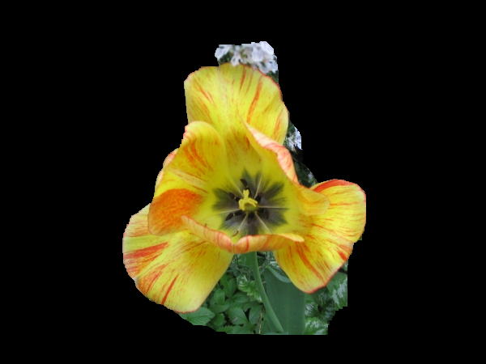

Same for the sheep: (100 100 600 600)

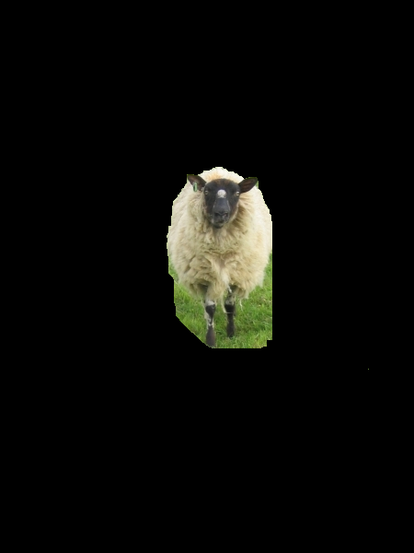

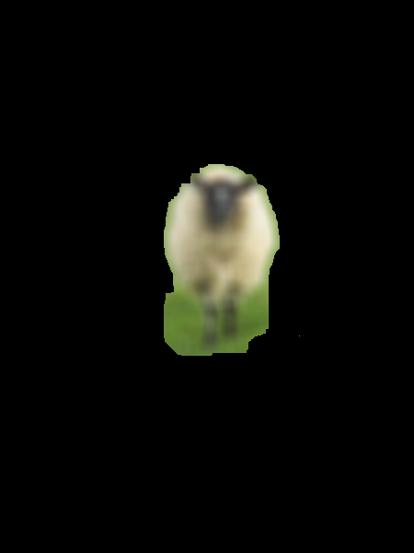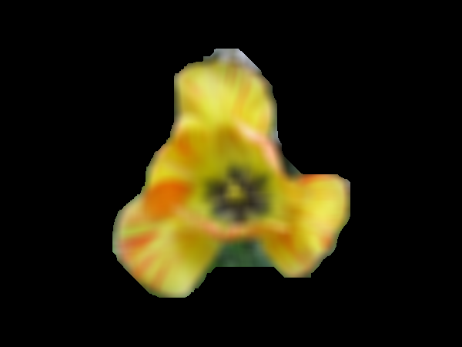Blur effect: I expect that bluer will make the edges less bolting then the gradiant will be smaller and the final results would be not good as before:

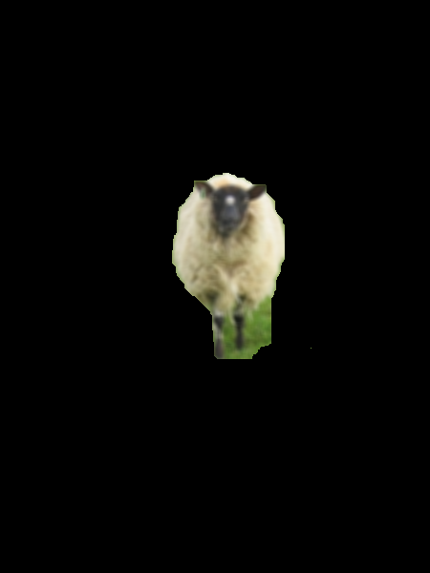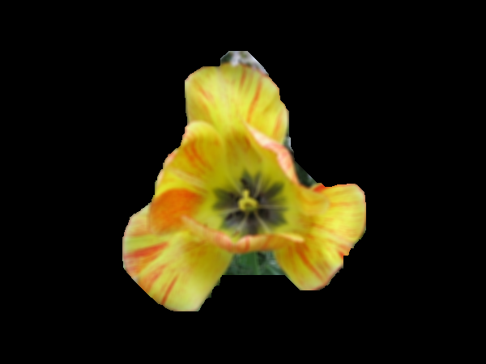

After looking at results we can see our prev assumption is not correct since the results are quite good. Possible explanation could be that the bluring is uniform in the sense it keeps the originals relations between pixels therfore our algorithm can still work in effitiant way.

So, to summarize the grab cut part. It was a good experience overall. I think even that we didn't got optimal results we managed to learn the algorithm and how he works. Especially, I think there a uge gap between understanding the main idea of this algorithm and really implementing it without errors. Again if had more time to invest I'm sure we where crcking it eventully.

**Poisson Blending:**

**Blending results (backgrounds were chosen randomly):**

**banana1 on the table background:**

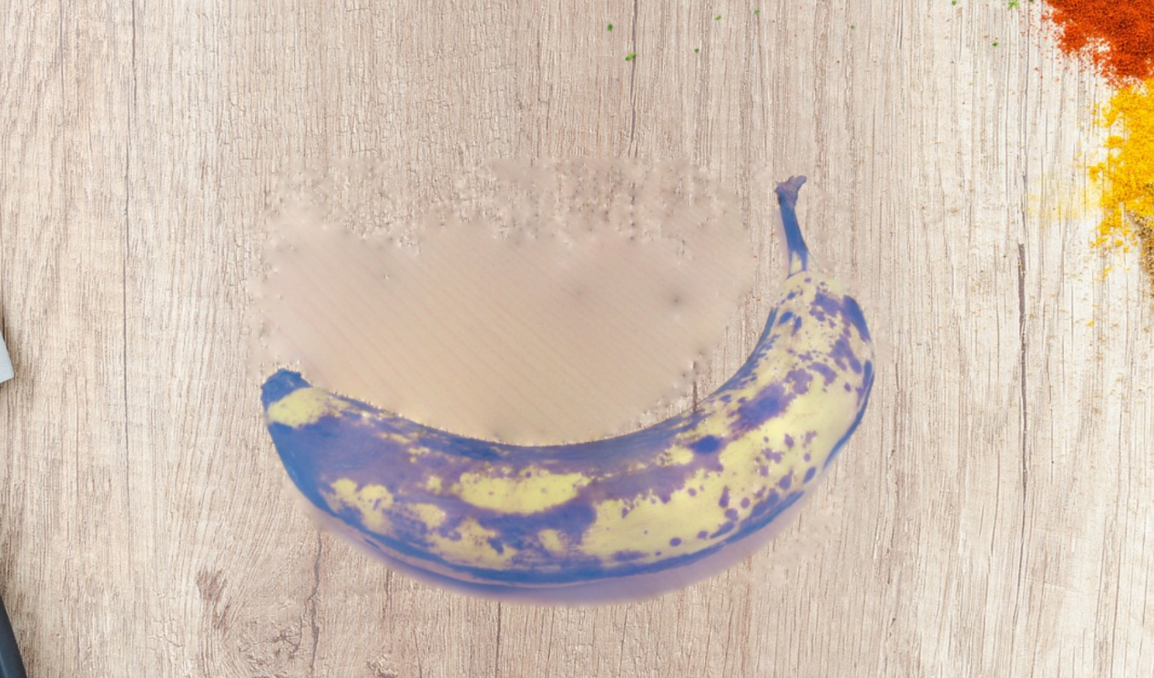

**banana2 on the wall background:**

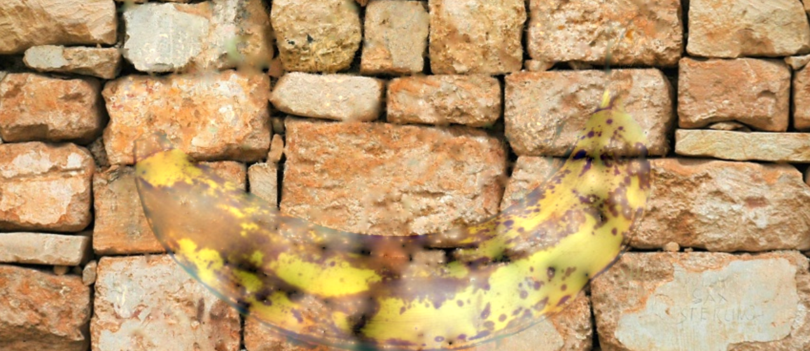

**book on the table background:**

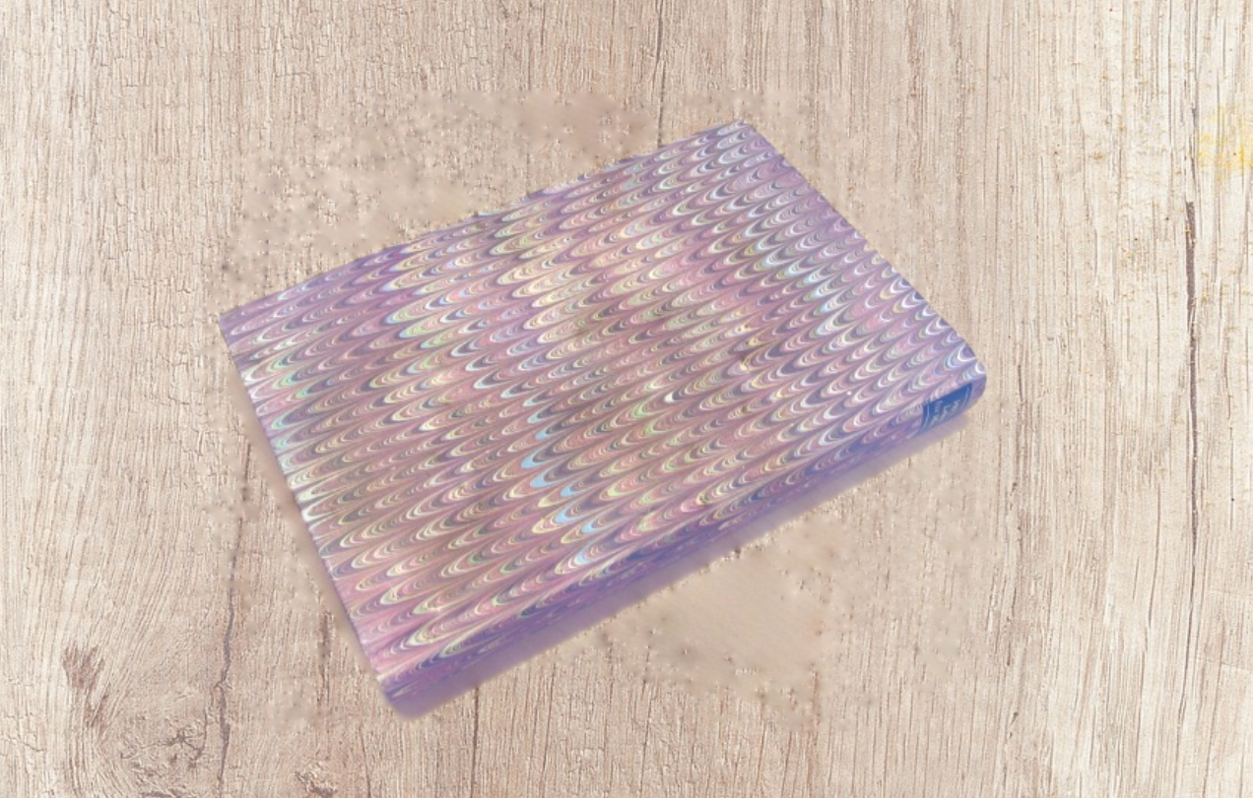

**bush on the table background:**

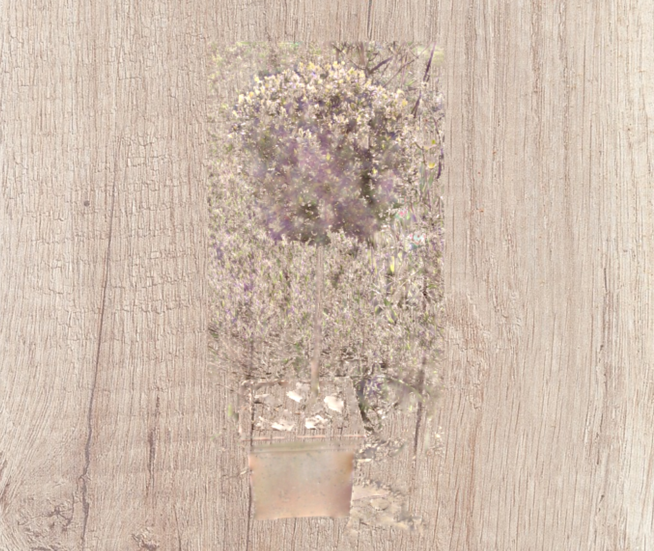

**cross on the grass mountains background:**

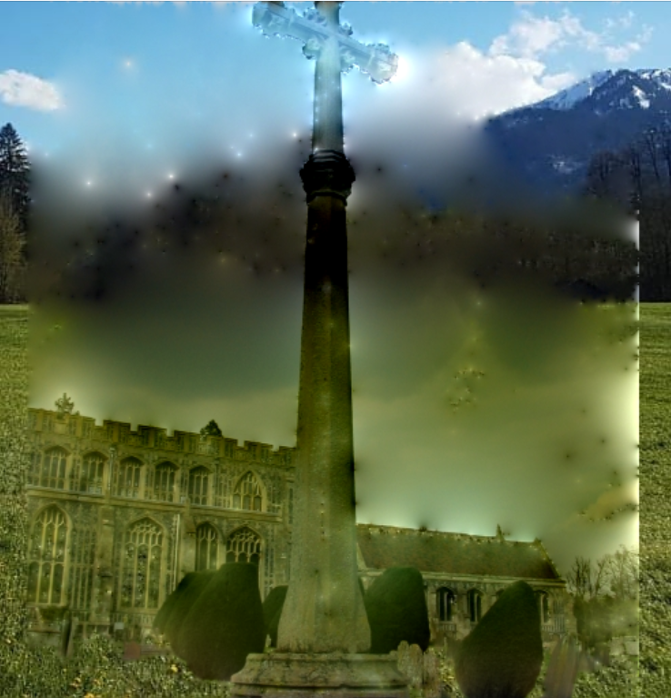

**flower on the wall background:**

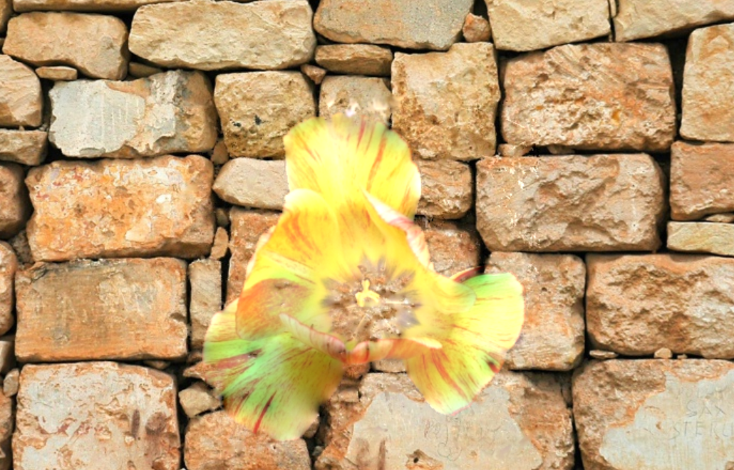

**fullmoon on the table background:**

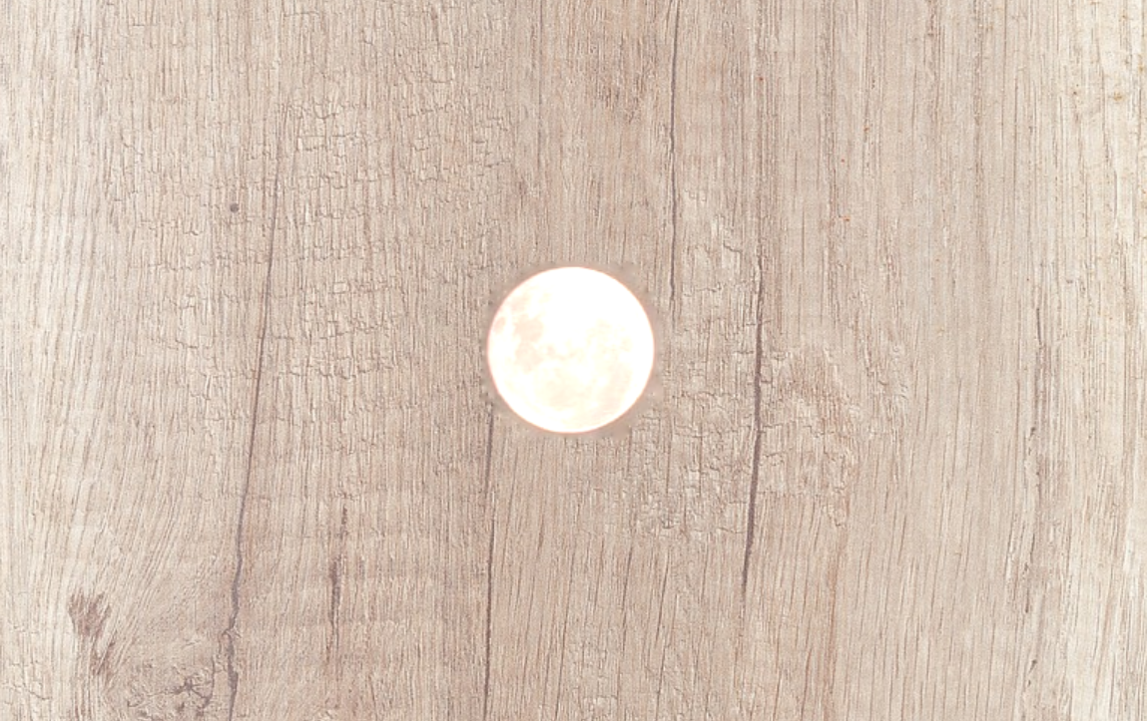

**grave on the wall background:**

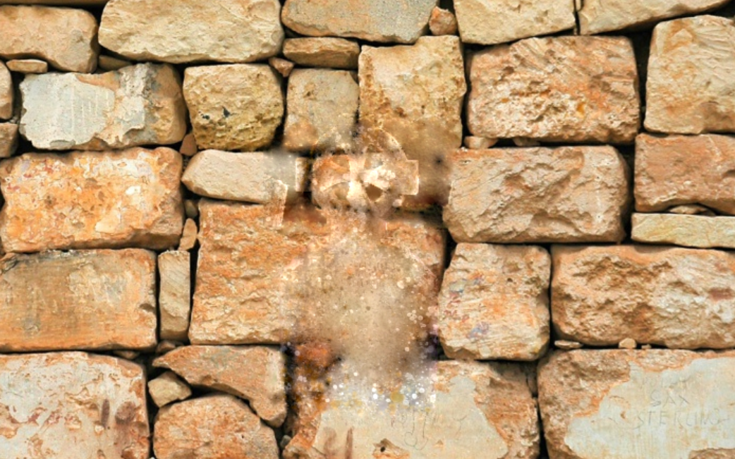

**llama on the grass mountains background:**

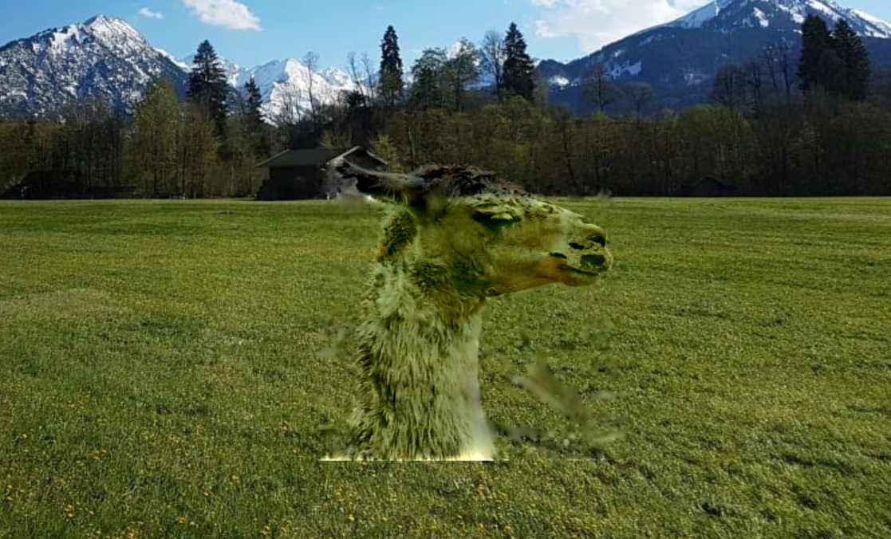

**memorial on the table background:**

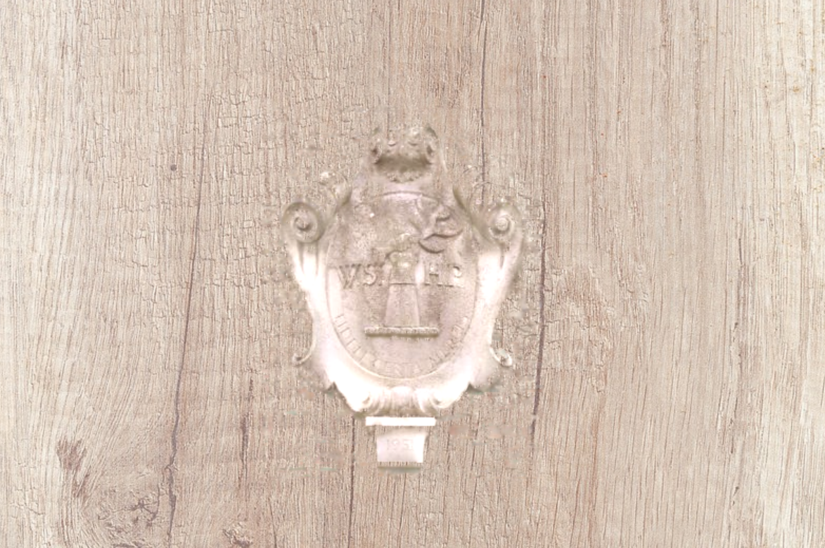

**sheep on the grass mountains background:**

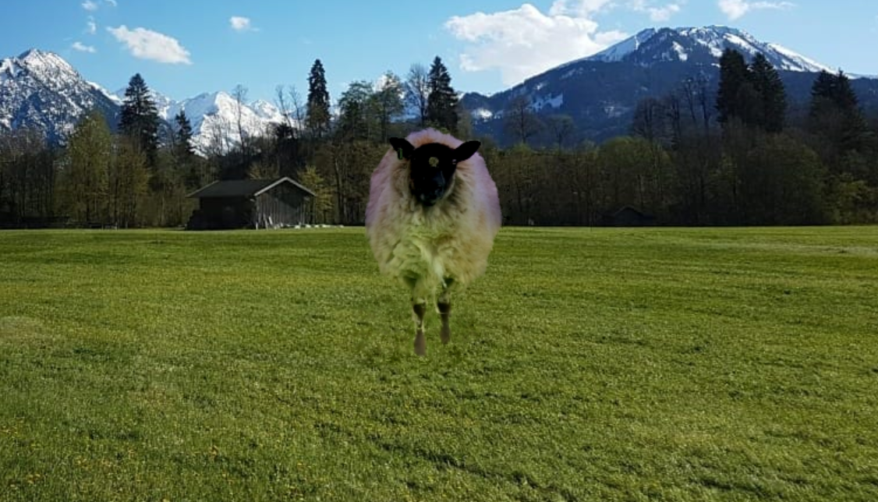

**stone2 on the grass mountains background:**

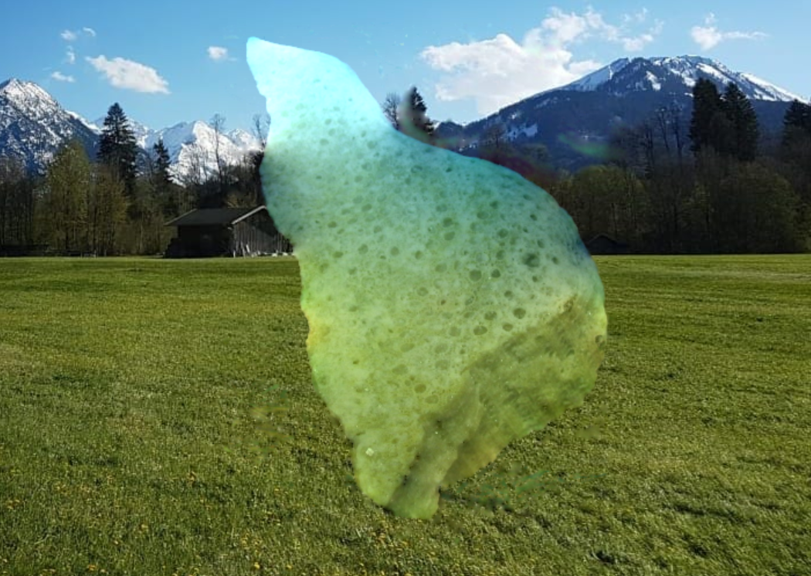

**teddy on the table background:**

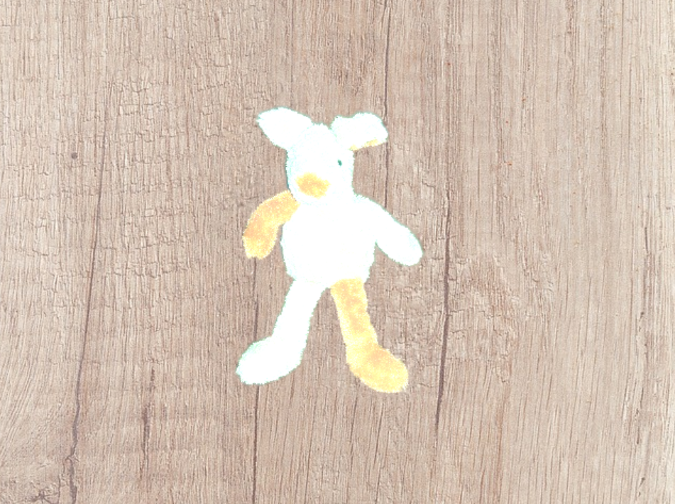

For the second part of the Poisson Blending report we chose the cross and bush images on the background grass mountains to show what happens if the mask is not tight around the object -

**The GrabCut mask of the cross (obviously not tight around the cross) -**

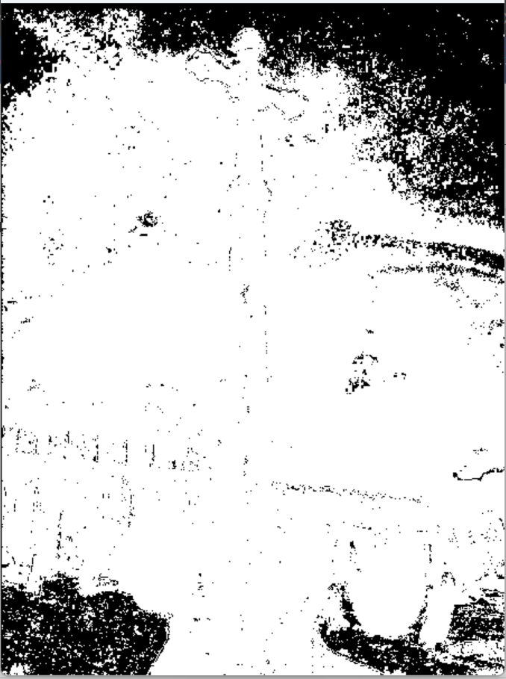

**Original cross:**

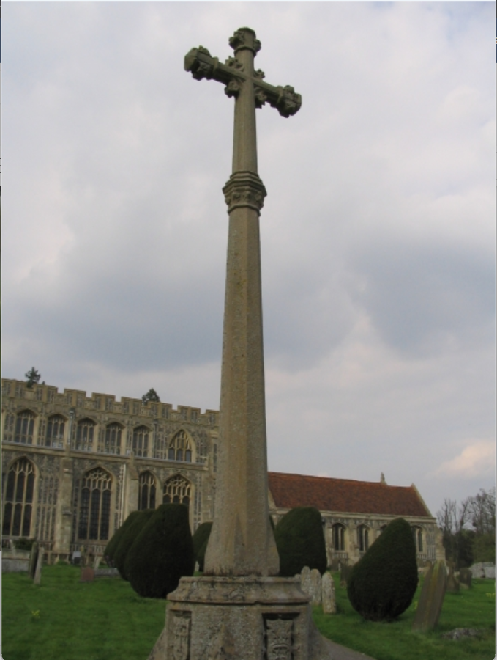

**cross on the grass mountains background:**



As can be seen in the blended image of the cross, the result of an untight mask around the object makes the background of the source image to appear around the object in the target image, in our example it is pretty noticeable (the buildings around the cross appear pretty hard) since the mask was very not tight.

**The GrabCut mask of the bush (obviously not tight around the bush) -**

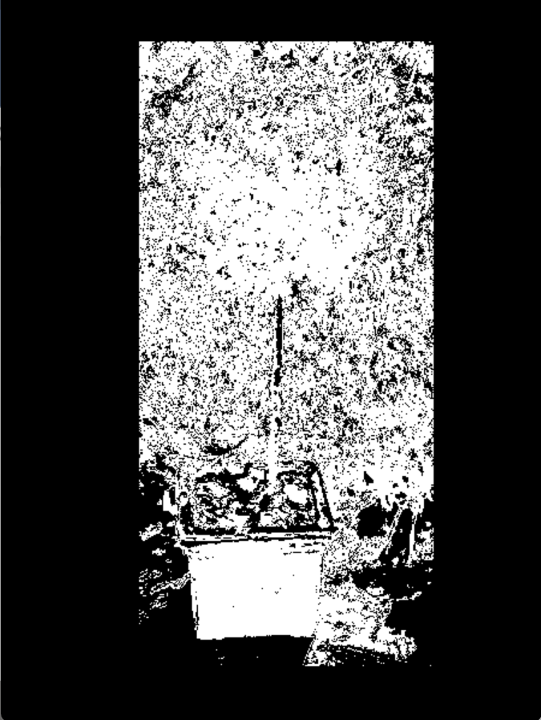

**Original bush -**

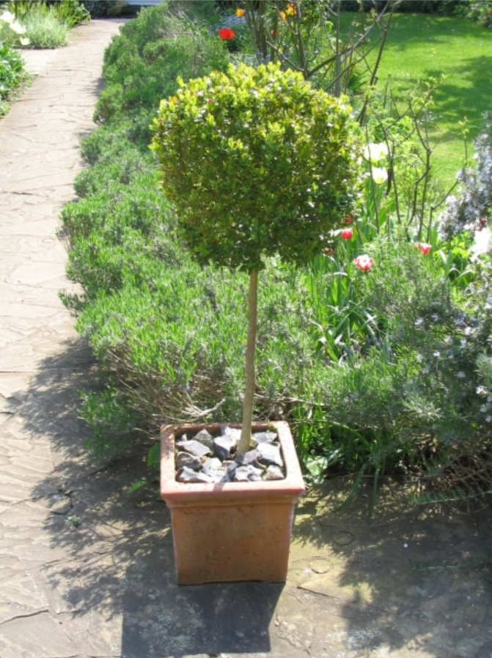

**bush on the grass mountains background:**

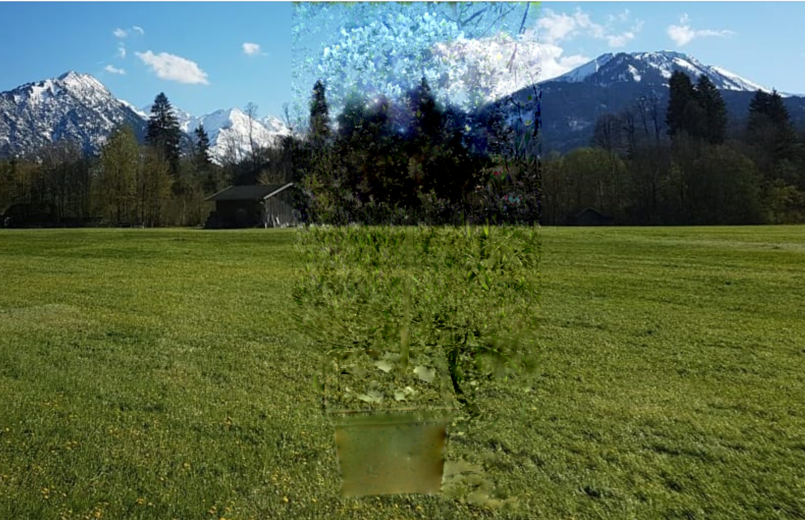

In the blended image of the bush we can see the same effect we saw in the cross, it is a bit less obvious since the mask of the bush is less accurate but it is noticeable that in the lower part of the object, where the flowerpot is, since the mask is tighter there we see mainly the flowerpot outlines, however along the stem of the bush where the mask is much less tight we see the background of the object in the original source image.